**Murshidabad** **College of Engineering**

**& Technology**



**Minor Project Report on: CPDMS**

SHUVRADIP CHAKRABORTY

Roll No : 25

Stream : BCA

Semester : 5th

Subject code : BCAN-591

**Minor Project Report submitted for the partial fulfillment of B.C.A. on PHP, HTML, CSS & JavaScript**

Presented to **Maulana Abul Kalam Azad University of Technology**

**( Formerly Known as WBUT )**

**Our Team Members Are:**

|  |  |  |
| --- | --- | --- |
| **Sl. No.** | **Name** | **Roll No.** |
| **1** | **Shuvadip Chakraborty** | **25** |
| **2** | **Mainak Podder** | **15** |
| **3** | **Sibendu Ghosh** | **18** |
| **4** | **Sushmita Sarkar** | **1** |
| **5** | **Abhijit Mondal** | **7** |
| **6** | **Antara Kangsabanik** | **44** |

**Acknowledgement**

I humbly acknowledge my best to all those who helped and guided me for completion of my dissertation work. I wish to express my deepest gratitude to my domain supervisor Mr. Debarghya Chakraborty, Faculty of BCA for his humble and inspiring guidance throughout the preparation of the dissertation report entitled “Project Title”. I am grateful to him for providing me requisite facilities. Successful completion of the project was not possible without his guidance.

It is only his precious and effective suggestion in our work which constantly encouraged me to go ahead and enable me

to give this project report its present shape.

I am also very thankful to our faculty members and friends for giving their valuable time and moral support.

I acknowledge my gratitude to our Principal In Charge & HOD(BCA) Sir, MCETSM, Berhampore for encouraging my project work.

Submitted By:

Student Name

(**Registration no of YEAR** )



MURSHIDABAD COLLEGE OF ENGINEERING & TECHNOLOGY, BERHAMPORE

(MAULANA ABUL KALAM AZAD UNIVERSITY OF TECHNOLOGY)

**CERTIFICATE OF APPROVAL**

*This is to certify that the project entitled “PROJECT TITLE” which is being submitted to the MURSHIDABAD COLLEGE OF ENGINEERING & TECHNOLOGY, BERHAMPORE (Under Maulana Abul Kalam Azad University of Technology) for the award of the degree of BACHELOR OF COMPUTER APPLICATION (BCA) by STUDENT NAME, Roll No : _____OF YEAR , is a record of bonafide project work carried out by him under our supervision and guidance. The project has reached the standard fulfilling the requirements of the regulations to the degree. We further certify that the project have not been previously submitted to any other University or Institute for the award of any other degree or diploma.*

**Date :**

**…………………………………………..**

**Place: Mr. Debarghya Chakraborty**

Project Guide,

Assistant Professor

Department of BCA, MCETSM

**…………………………………………………………………..**

**Mr. Swagata Mandal**

Head of the Department of BCA, MCETSM

**…………………………………………………………………..**

**Signature of the Examiner**

**INDEX**

|  |  |
| --- | --- |
| **Item** | **Page**  **No.** |
| **Abstract** | **6** |
| **About the project** | **8** |
| **Problem Definition & Feasibility Analysis** | **9** |
| **Requirement Specification** | **13** |
| **System Design** | **15** |
| **Software Tools** | **16** |
| **Data Volume Analysis** | **20** |
| **Testing** | **21** |
| **Entity Relationship(ER) Diagram** | **23** |
| **Data Flow Diagram(DFD)** | **24** |
| **Database Screenshots** | **25** |
| **Project Screenshots** | **26** |
| **Conclusion & Enhancements** | **33** |
| **Bibliography** | **34** |

**ABSTRACT**

COVID-19 Portal is envelope non-segmented positive Sense RNA viruses belonging to family Coronaviridae. On the Whole the objective of the project is to aware people about Coronavirus. It provide information about preventive method, Symptoms, precaution e.t.c. Apart from this there will be an Admin module for this to make changes to the database Content.

It consist 7 modules:

1. Home

2. Prevent

3. Symptoms

4. Precaution

5. Doctors

6. Center And Map

7. Contract

**Home:** This module content details about Coronavirus &In which condition it will survive the longest and how it spread all over the world It helps You to identify What Is Novel Coronavirus , What is long covid and In What Conditions Does COVID-19 Survive The Longest?

**Prevent:** This module content details about how we take Prevention method against Corona virus. There Is Currently No Vaccine To Prevent Coronavirus Disease 2019 (COVID-19). The Best Way To Prevent Illness Is To Avoid Being Exposed To This Virus. Stay Aware Of The Latest Information On The COVID-19 Outbreak, Available On The WHO Website And Through Your National And Local Public Health Authority.

**Symptoms:** This module content details about in which Lest common and most common Condition people suffer if they are attacked by Corona virus. MOST COMMON SYMPTOMS Coronavirus Disease (COVID-19) Is An Infectious Disease Caused By The SARS-CoV-2 Virus. Most People Who Fall Sick With COVID-19 Will Experience Mild To Moderate Symptoms And Recover Without Special Treatment. However, Some Will Become Seriously Ill And Require Medical Attention.

**Precaution:** This module content details about how People fight against Coronavirus by vaccinated, using sanitizer Mask e.t.c. take precautions against covid-19 Like get vaccine and were a mask and use sanatizers

**Doctors:** This module content about the details of Doctors , ambulance services, emergency rooms, free Checkups e.t.c. we have some doctors whom have treated patients with check-ups and medicine

**Center and map:** This module content in which centre Is available for vaccination. With their name , contract number ,CVC number, name of block, type of CVC and type of vaccine and full description of them with complete Google map view available

**Contact:** This module content how people contact with us for their problems. Where we tale their full name, age, Telephone, email, symptoms and type of symptoms and full description of their for full understanding

**About the project:**

The project aims to develop content in the COVID-19 Category and also the respiratory and mental health section Of physiopedia as a response to the COVID -19 pandemic. We Initiated this site with practical , credible information on all Aspect of management of individuals with a diagonosis of COVID-19.

Here we describe about the cause and effect of COVID-19

* Here we describe how people are contact with our doctors And Health Hospitals In Murshidabad and Nadia
* Here we also Want to aware people and also we provide critical information for the people who needed the most
* The details of doctors and hospitals, we also describe the Symptoms so that they can take prevention method.

## PROBLEM DEFINITION AND FEASIBILITY ANALYSIS

**Definition of the problem:**

To create or develop a new system first we have to study the prior system, Analysis difficult problems faced by the operator of that system. System Analysis therefore understands such problems and proposes a new system in which the above problems are rectified.

**Existing system:**

Before creating this website, all patients had to send go to the doctors chamber or get information through relatives or they use person to person contacts with each other. It will take long time to send their requirements through this type of communications.

Here there May error occurs in the process. The doctors faces the problems to collect all the information from patients and consultants to analyze the requirement in the corresponding patiens. Administration has to send requirements information to different Hospital and Doctors.

**Proposed System:**

Here all covid patients information through our site. It does not consume much of time. .It is very easier to modify if any error occurs in the process. It is also very easier to administrator to collect information from Doctors and Hospitals

**Users of the system:**

The users of this system are the patients, job hospitals or doctors and local Ngo . This system is designed such a way that the users can easily interact with the system with minimum knowledge to browser the net and company rules.

**Module Description:**

The proposed system is developed by using seven modules:

* + 1. Home
    2. Prevent
    3. Symptoms
    4. Precautions
    5. Doctors
    6. Centre and Map
    7. Contract

**Home:**

This module contains details about Coronavirus its details with pictures and videos , i.e. text, and image details. Like Long covid, Map of its spread , and other details Here people can educate themselves about covid in a fun and engaging way . He can update His understanding about this virus also.

**Prevent:**

This module having information about prevention and protection against covid-19, which is helpful for everybody to understand and what based them recruiting the employees. Here client releasing the primary skills, experience, no. of vacancies, opening date, closing and closing date.

**Symptoms:**

This module is consisting details about Symptoms of covid-19 and their major as well and minor symptoms as the name suggests its tells the symptoms that covid can have and it`s consequences it also have a common questions section

**Precautions:**

This module is consisting details about the precations that we can take to help us fight corona as well and do certain things as the name suggests its tells the precations that covid-19 patients can have

**Doctors:**

This module is consisting details about Doctors for covid-19 and their facilities and the gallery of hospitals and the name and images of doctors to easily find all the info needed to a patients at one place

**Centre and Map:**

This module is consisting details about Covid-19 vaccination centres of covid-19 patients and the vaccination centers Name their cvc number, cvc name, name of block, type of cvc, type of vaccine, and necessary details as well as the facility of locating the vaccination centres in google map with oneclick

**Contract Us :**

This module is consisting details about Contracting with us to help with their problems and to store the details in a highly available database the patients can send their problems by simply filling a form with necessary details and we can spread the details to the hospitals nearby

**Administrator:**

The administrator module having all privileges about this entire project, he can update, delete, and modify the details about the pages of our web applications like Home, patients, symptoms and center and Map. Administrator maintain the records in a database, and whenever the This module provides the user with the privilege to update the latest information in the system without any coding knowledge It uses standardized technology to achieve that thanks to the WYSIWYG editor its possible for any one change the website information without messing with code

**Module connectivity:**

In the administrator module In this module we integrate both the front and the backend of the It will work as a bridge between the front end and the back end the data of the frontend can be changed using the systems at the back end and only the administrator can access it the backend is a specially built using PHP Apache JavaScript and other technology and the entire thing is connected using it my SQL database

**Feasibility study:**

It is necessary and prudent to evaluate the feasibility of a project at the earliest possible time. There may be different ways of checking whether a system is feasible or not. The following feasibility studies were performed to gauge the feasibility of the system.

**Operational Feasibility:**

In this test, the operational scope of the system is checked. The system under consideration should have enough operational reach. It is observed that the proposed system is very user friendly and since the system is built with enough help, even persons with little knowledge of windows can find the system very easy.

**Technical Feasibility:**

This test includes a study of function, performance and constraints that may affect the ability to achieve an acceptable system. This test begins with an assessment of the technical viability of the proposed system. One of the main fusers to be accessed is the need of various kinds of resources for the successful implementation for the proposed system.

**Economical Feasibility:**

An evaluation of development cost weighed against the ultimate income or benefit derived from the development of the proposed system is made. Care must be taken that incurred in the development of the proposed of the system should not exceed from the system. The income can be in terms of money or goodwill, since the software brings in both, the system is highly viable

**Requirement Specification**

**Hardware and Software Specification:**

The development of this project deals with the following environment

1. **Hardware requirements**
2. **Software requirements**

**Hardware Requirements**:

The selection of hardware is very important in the existence and proper working of any software. In the selection of hardware, the size and the capacity requirements are also important.

The Covid-19 Portal can be efficiently run-on Pentium system with at least 128MB RAM and Hard disk drive having 20GB. And at least 14inch color monitor suits the information system operation. (A Printer is required for hard copy output).

|  |  |  |
| --- | --- | --- |
| * Pentium processor * RAM Capacity * Hard Disk | --------  --------  -------- | 233 MHZ or above  128MB  20GB |
| * CD-ROM Drive | -------- | 32HZ |
| * KEYBOARD | -------- | 108 Standard |

**Software Requirements**:

One of the most difficult tasks is that, the selection of the software, once system requirement is known is determining whether a particular software package fits the requirements. After initial selection further security is needed to determine the desirability of particular software compared with other candidates. This section first summarizes the application requirement question and then suggests more detailed comparisons.

|  |  |  |
| --- | --- | --- |
| * Operating System | -------- | Windows 95/98/NT/2000/XP/7/8 |
| * Browser | -------- | IE, Mozilla, Google Chrome etc. |
| * Database Server | -------- | ORACLE |
| * Database Connectivity | -------- | SQL |
| * Other Tools & Technologies | -------- | PHP, JAVASCRIPT. HTML |

**SYSTEM DESIGN**

5.1 **Design Description**

Design is essentially a blue print or it acts as a bridge between the requirement specification and the final solution for satisfying the requirements. Based on the work-flow described above we can draw the following conclusions for the Software System that has to be developed:

• The System needs to be a web-based system so that it allows the patients , Clients & Ordinary People to access the company database over the Internet.

• Being a web-based system also enables the Hospital staff to Contract Us immediately to help, whenever a requirement for Help arises.

• An added advantage is since the Submitting is delivered instantly, there could be instant responses from the patients.

• The whole process depends on communications between patients & the Hospital Staff & the Doctor. If all these communications are done through a web-based system, then the time period for the whole process can be considerably brought down.

• The System needs to store the details of all the Doctors.

• The System needs to store the details of all the information (Name, age, any symptoms, and A Descriptive Message etc.) held by all the patients.

• The System needs to store the details of all the requirements held in the different clients.

• The System needs to store the details of all the patients held in the Database.

• The System needs to store the details of all the Doctors.

• Since it is a web-based system, a Login authorization should be provided so that Consultants, patients , and clients will be able to lookup & use options that are specific to them.

• The System should allow the patients to enter their Details.

• The System should allow the Doctors to provide Services To Their patients .

• The System should provide an option to Store a patients Report.

• The System should provide an option to Store a Website Data In A Database.

• The System should provide an option to Find Vaccination Centre Online .

**SOFTWARE TOOLS**

**OVERVIEW OF PHP:**

**What is PHP?**

PHP (P - Hypertext Preprocessor) is a widely-used open-source general-purpose scripting language that is especially suited for web development and can be embedded into HTML. PHP is a server-side scripting language designed for web development but also used as a general-purpose programming language.

**Why we used php in our project?**

Top Three Reasons to use PHP:

**1.) Works Great with HTML** - If you already have a website and are familiar with HTML, making the step to PHP is easy. If fact, PHP and HTML are interchangeable within the page! While PHP might add some new features to your site, its basic appearance is still all created with HTML. Read more about PHP with HTML.

**2.) Interactive Features** - PHP allows you to interact with your visitors in ways HTML alone can't. This can mean simple things like e-mail forms, or more elaborate things like shopping carts that save your past orders and recommend similar products. It can also mean social things like interactive forums and private messaging systems. See some examples.

**3.) Easy to Learn** - PHP is a lot easier to get started with than you might think. By learning just a few simple functions, you are able to do a lot of things with your website. And once you know the basics, there are a wealth of scripts available on the internet that you only need to tweak a little to fit your needs. Start learning PHP.

**Features of php:**

• It is extremely fast.

• No template parsing overhead, only compiles once.

• It is smart about recompiling only the template files that have changed.

• You can easily create your own custom functions and variable modifiers, so the template language is extremely extensible.

• It is possible to embed PHP code right in your template files, although this may not be needed (nor recommended) since the engine is so customizable.

**Advantages of PHP**:

• Open source: It is developed and maintained by a large group of PHP developers, this will help in creating a support community, abundant extension library.

• Speed: It is relative fast since it uses much system resource.

• Easy to use: It uses C like syntax, so for those who are familiar with C, it’s very easy for them to pick up and it is very easy to create website scripts.

• Stable: Since it is maintained by many developers, so when bugs are found, it can be quickly fixed.

• Built-in database connection modules: You can connect to database easily using PHP, since many websites are data/content driven, so we will use database frequently, this will largely reduce the development time of web apps.

• Can be run on many platforms, including Windows, Linux and Mac, it’s easy for users to find hosting service providers.

**Disadvantages of PHP:**

• Security: Since it is open sourced, so all people can see the source code, if there are bugs in the source code, it can be used by people to explore the weakness of PHP

• Not suitable for large applications: Hard to maintain since it is not very modular.

**Why Choose PHP Over Other Web Development Languages?**

1. **Fast and Reliable**: Any other programming language is not always as fast and reliable as PHP. Moreover, the other web development languages are not the easiest as far as usage and configuration is concerned. PHP-made applications are generally easy and quite simple to follow and can easily synchronize to a good number of possibilities. PHP does make use of a good number of system resources. Even while using along with other software applications, PHP retains its speed without slowing down the overall process.

2. **Platform Independent:** Talking about independence, PHP works with a number of platforms like Mac OS X, Windows, Linux, and UNIX. It also supports a good number of back-end databases like MySQL, Oracle and the likes. It is because of these facilities that PHP is more of an independent platform, having the capability of being deployed in almost any environment.

3. **Higher Performance, More Flexible and Enhanced Graphics**: With the manner in which PHP is built, you can surely develop high performance applications in an easy manner. Not just performance, but the associated flexibility, scalability and enhanced graphics make it an ideal choice for all web development projects.

4. **Open Source**: PHP is a multi-purpose open-source language that can be downloaded for free from over the internet. This feature alone has made the programming language popular among the developers who are handling tight budget projects. Not only PHP is available for free download, but also the updates have zero cost associated with them. This makes PHP one of the most budget friendly languages available out there.

**ABOUT HTML**

HTML (hypertext markup language) is a language used to create hypertext documents that have hyperlinks embedded in them. it consists of tags embedded in the text of a document with HTML. We can build web pages or web document s. it is basically a formatting language and not a programming language. The browser reading the document interprets markup tags to help format the document for subsequent display to a reader. HTML is a language for describing structured documents. HTML is a platform independent. www (world wide web) pages are written using HTML. HTML tags control in part the representation of the WWW page when view with web browser. The browser interprets HTML tags in the web document and displays it. Different browsers show data differently. Examples of browsers used to be web pages include:

• Netscape

• Internet Explorer

**About MySQL:**

MySQL, the most popular Open-Source SQL database management system, is developed, distributed, and supported by Oracle Corporation.

• **MySQL is a database management system**.

A database is a structured collection of data. It may be anything from a simple shopping list to a picture gallery or the vast amounts of information in a corporate network. To add, access, and process data stored in a computer database, you need a database management system such as MySQL Server.

• **MySQL databases are relational**.

A relational database stores data in separate tables rather than putting all the data in one big storeroom. The database structures are organized into physical files optimized for speed. The logical model, with objects such as databases, tables, views, rows, and columns, offers a flexible programming environment. The SQL part of “MySQL” stands for “Structured Query Language”. SQL is the most common standardized language used to access databases. Depending on your programming environment, you might enter SQL directly (for example, to generate reports), embed SQL statements into code written in another language, or use a language-specific API that hides the SQL syntax.

• **MySQL software is Open Source**.

Open Source means that it is possible for anyone to use and modify the software. Anybody can download the MySQL software from the Internet and use it without paying anything. If you wish, you may study the source code and change it to suit your needs.

• **The MySQL Database Server is very fast, reliable, scalable, and easy to use.**

MySQL Server can run comfortably on a desktop or laptop, alongside your other applications, web servers, and so on, requiring little or no attention. If you dedicate an entire machine to MySQL, you can adjust the settings to take advantage of all the memory, CPU power, and I/O capacity available. MySQL can also scale up to clusters of machines, networked together. Its connectivity, speed, and security make MySQL Server highly suited for accessing databases on the Internet.

• **MySQL Server works in client/server or embedded systems**.

The MySQL Database Software is a client/server system that consists of a multi- threaded SQL server that supports different backends, several different client programs and libraries, administrative tools, and a wide range of application programming interfaces (APIs).

• **A large amount of contributed MySQL software is available**.

MySQL Server has a practical set of features developed in close cooperation with our users. It is very likely that your favourite application or language supports the MySQL Database Server.

**Data Volume Analysis**:

1. **What are data volumes?**

ANS: In SAP, data volumes are the spaces defined in SAP to store data or log information. Otherwise, the English word volume means amount. A data volume is simply the amount of data in a file or database.

2. **How would you define them**?

ANS: You would calculate the amount of data storage for a website by figuring out how much data comes in per month, and multiply those times with the number of months you expect your web site to grow.

3. **How would you calculate the data volumes for a website**?

ANS: Most web sites just like disk storage as needed, rather than attempt to predict how much will be needed in the future. If you're Google or Facebook, you just plan to add disk storage space constantly. In our project When any employee registers his/her name then the value of the database is increased by 0.19kb.

Suppose, 1000 employee register his/her name in a day then the value is increased 190kb/per day. According to this monthly data volume can be increased by 190*30 = 5700kb = 5.56mb/monthly approx. And yearly increased 190*365 = 69350kb = 67.72 MB/yearly.

**TESTING AND IMPLEMENTATION**

Testing plays a critical role for quality assurance and for ensuring the reliability of the software. Its basic function is to detect the errors. After the coding phase, testing is done to test the proper working of the new system. Testing is the process of executing a program with the intention of finding errors. It is a complete verification to determine whether the objectives are met and the user requirements are satisfied. The testing phase involves testing of a system using various test data. Preparation of the test data plays a vital role in the system testing. After preparing the test data, the system under study is testing using those test data. Errors were found and corrected by using the following testing steps and corrections are recorded for future references. Thus, a series of testing is performed on the system before it is ready for coding. Since code is the only product that can be executed frequently, actual behaviour of which can be observed, this phase is so important for the successful implementation of the software product. Thus, the goal of testing is to uncover the requirements, design and coding errors in the program.

**Unit Testing**

The first step in the testing is the unit testing. Unit test is normally considered as an adjunct to the coding step. After the coding has been developed, received and verified for correct syntax, unit testing begins. The standalone modules were tested individually for their correct functionality, with the corresponding data. This ensures the reliability of the modules when integrated. Each and every module is tested independently with sample data and it was found that all modules are properly functioning. Using the unit test plans, prepared in the design phase of the system as a guide, important control paths are tested to uncover errors within the boundary of the modules. Boundary conditions were checked, all independent paths were exercised to ensure that all statements in the module are checked at least once and all error handling paths were tested. Each unit was thoroughly tested to check if it might fall in any possible situation. This testing was carried out during the programming itself. At the end of this testing phase, each unit was found to be working satisfactory, as regard to the expected output from the module.

**Integration Testing**

The second step in the testing process is the Integration testing. Integration testing is the systematic technique for constructing the program structure while conducting tests to uncover errors associated with interfacing. Integration testing was performed by integrating all the individual modules and the activities of the user such as loading layers, retrieving information from any functions applying themes based on the records present in the database etc. and is found that it works good to the examination of the end users. Hence, the objective of integration testing is to take unit tested modules and build a final program structure.

**Functional Testing**

This test involves testing the system under typical operating conditions with sample input values. Functional testing was performed on the system by giving existing industry id or plot number and a null or string as the input for any field in which case the user should be redirected to the same state with the appropriate message, rather than proceeding and crashing in the system. Functional testing was performed on the system by raising the demand with an eye to check all the validations. The total processing of the system is satisfactory with the following results.

**Acceptance Testing**

User acceptance test of a system is the factor for the success of the system. The system under consideration was listed for user acceptance by keeping constant touch with the perspective user of the system at the time of design, development and making changes whenever required for unit testing. The requirements of the customer are gathered at regular intervals at the developing site itself. The problems that are to be visualized through this tool are been gathered by the customer and are reported. The user at the user’s site carried this test. Live data entered and the system’s output was compared with what was manually prepared. Here the system has met the user’s requirement in the following fields:

1. Data Entry

2. Error Handling

3. Reporting and corrections

4. Data Access Protections

5. System Output

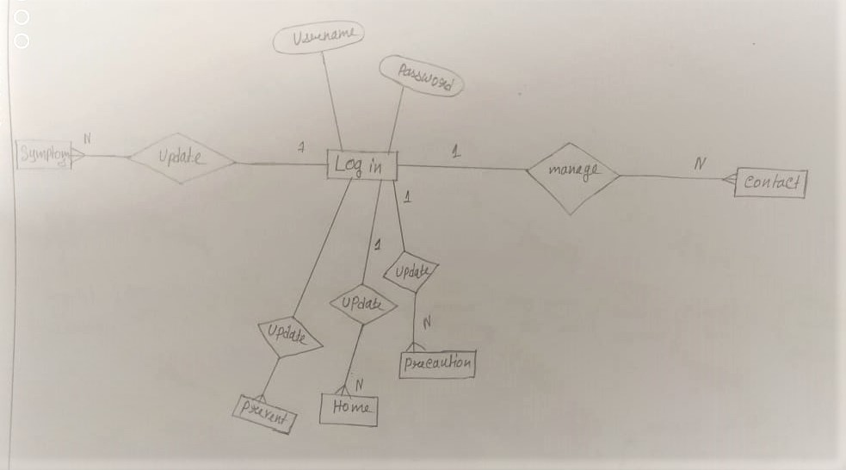**Entity Relationship(ER) Diagram:**

**Data Flow Diagram(DFD)**

* 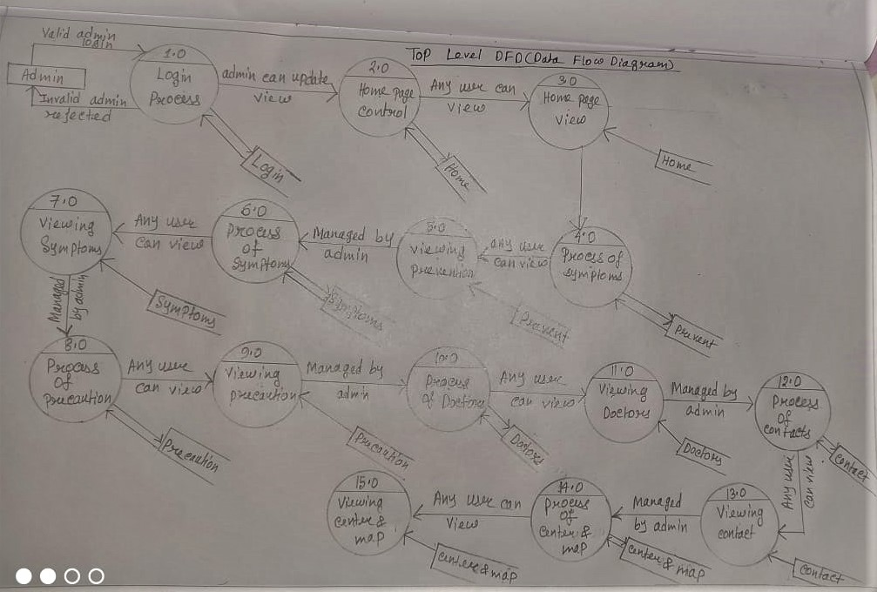**Top Level DFD:**
* 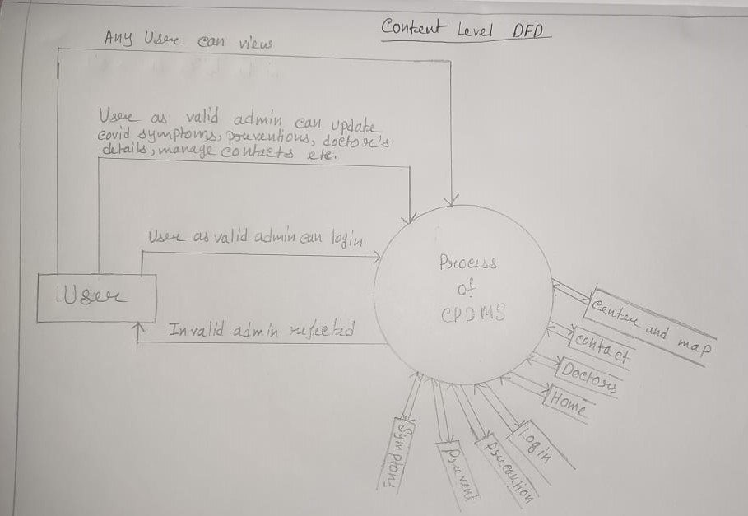**Context Level DFD:**

**Database Screenshots:**

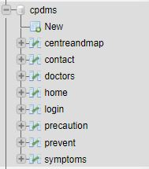

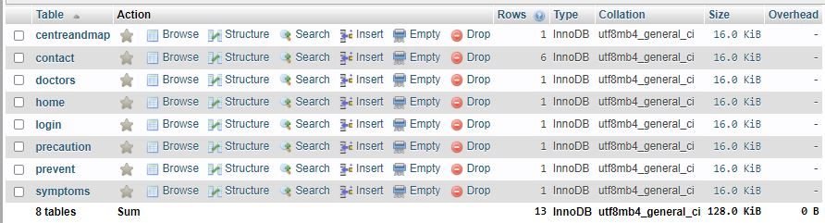

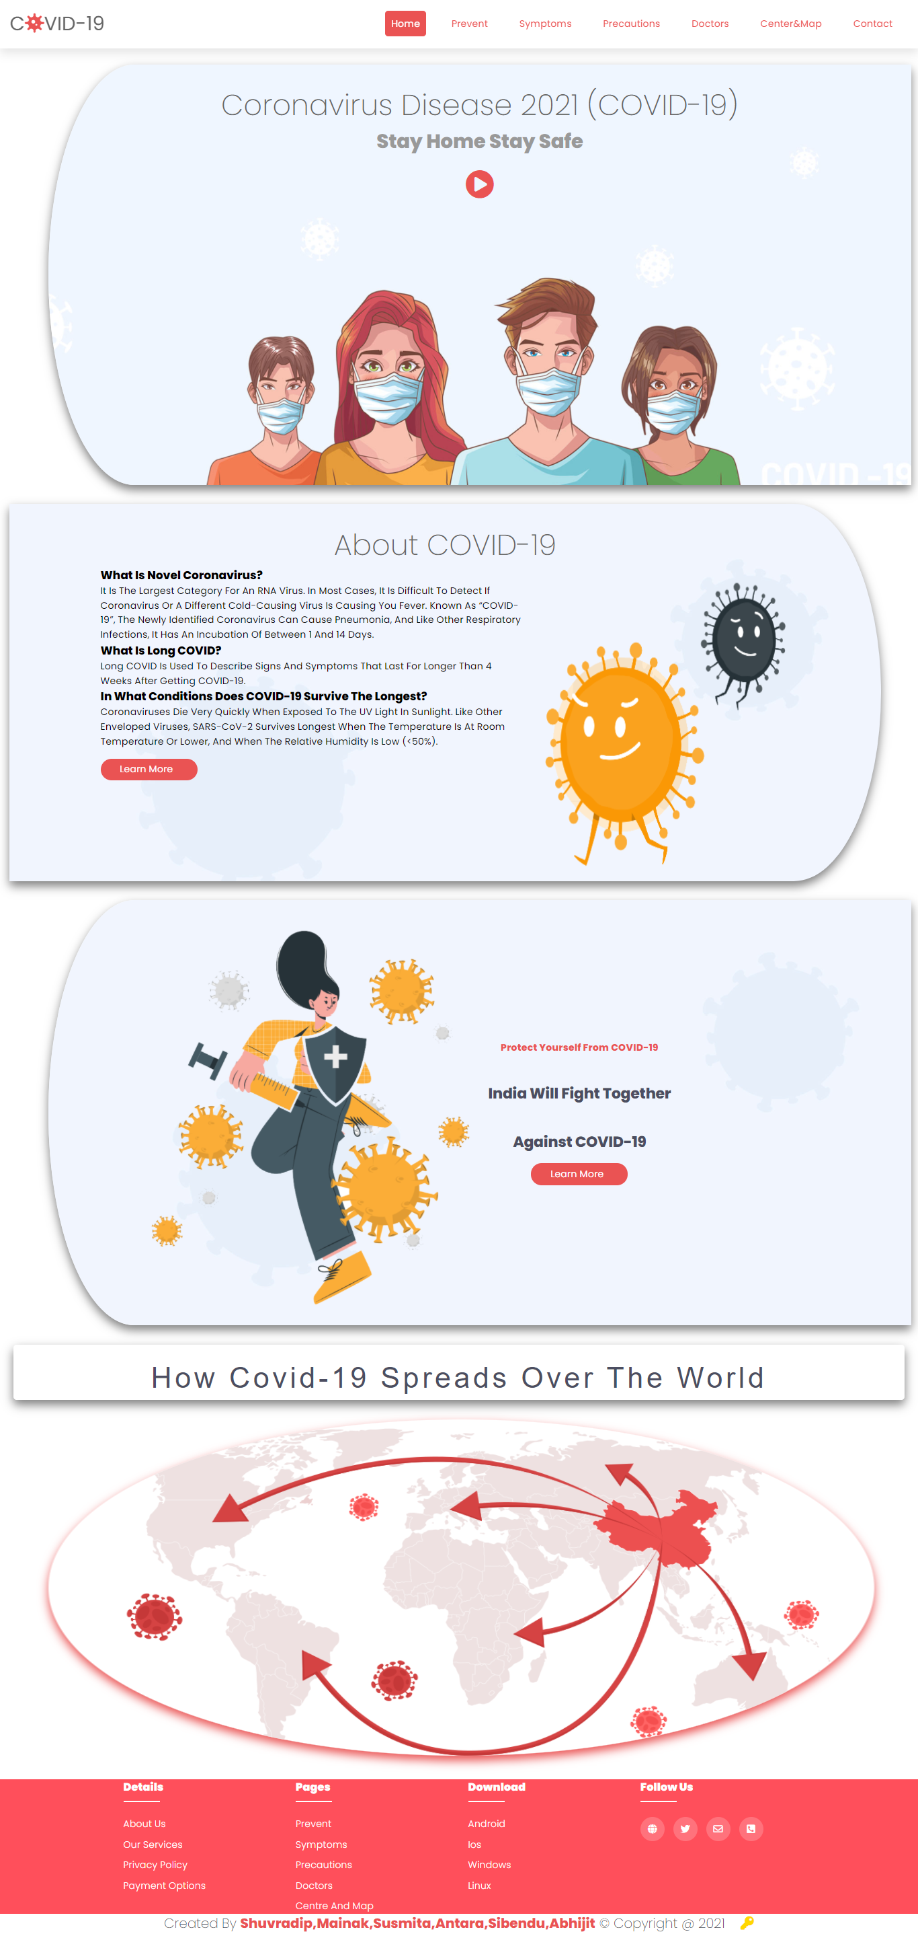**Project Screenshots:**

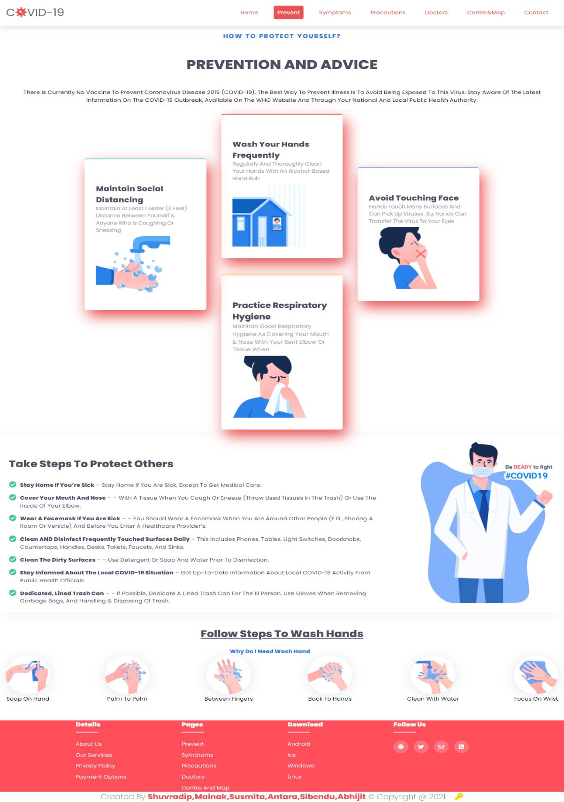

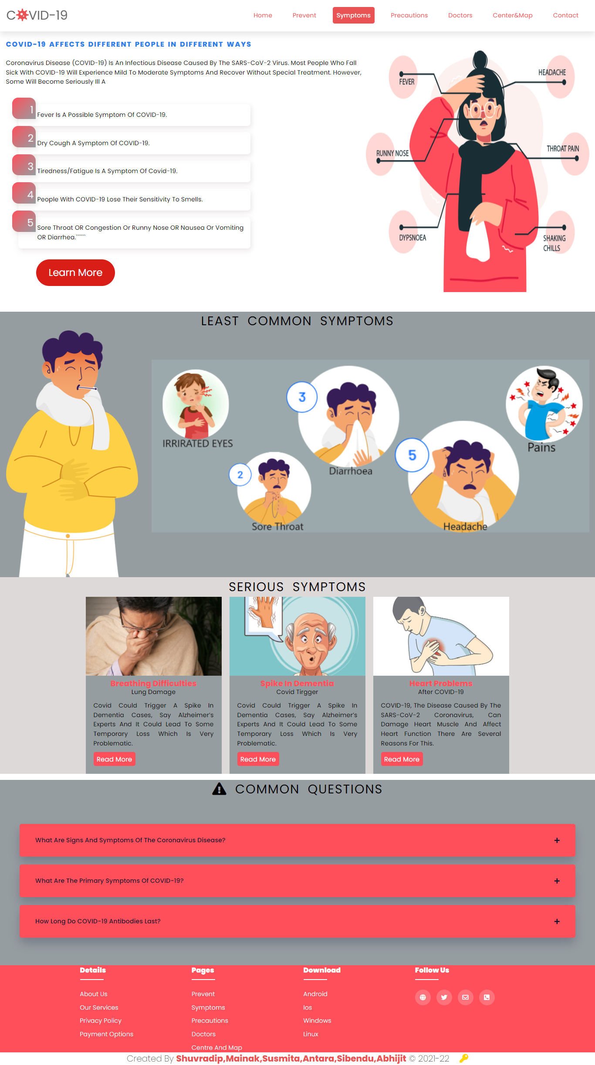

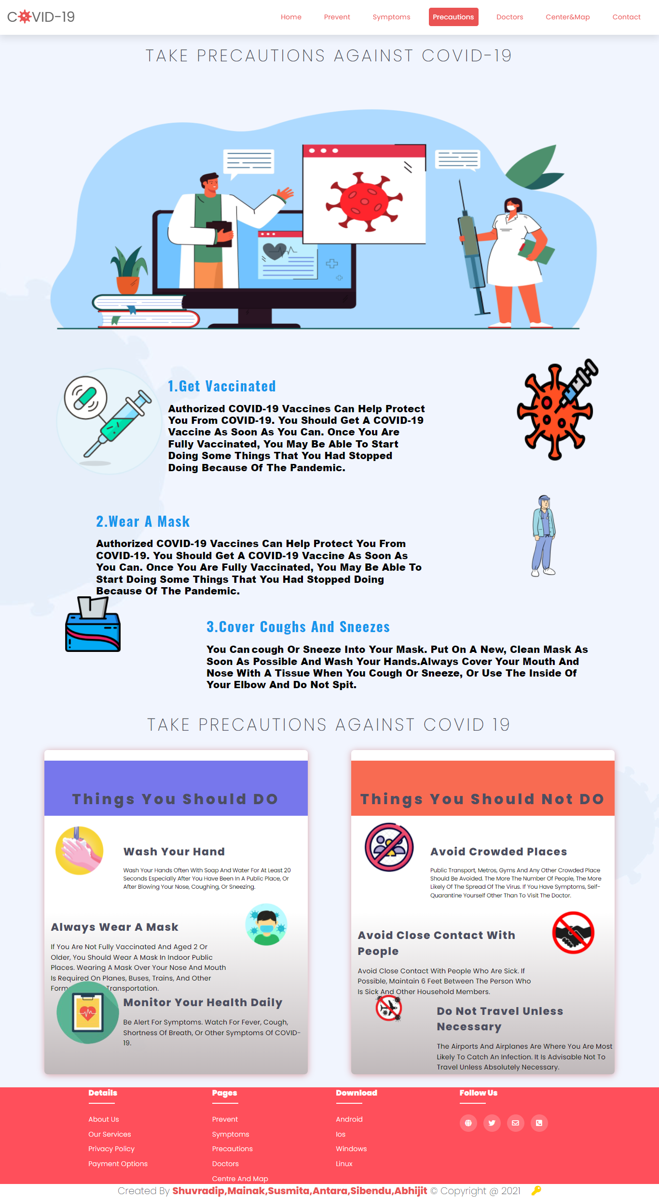

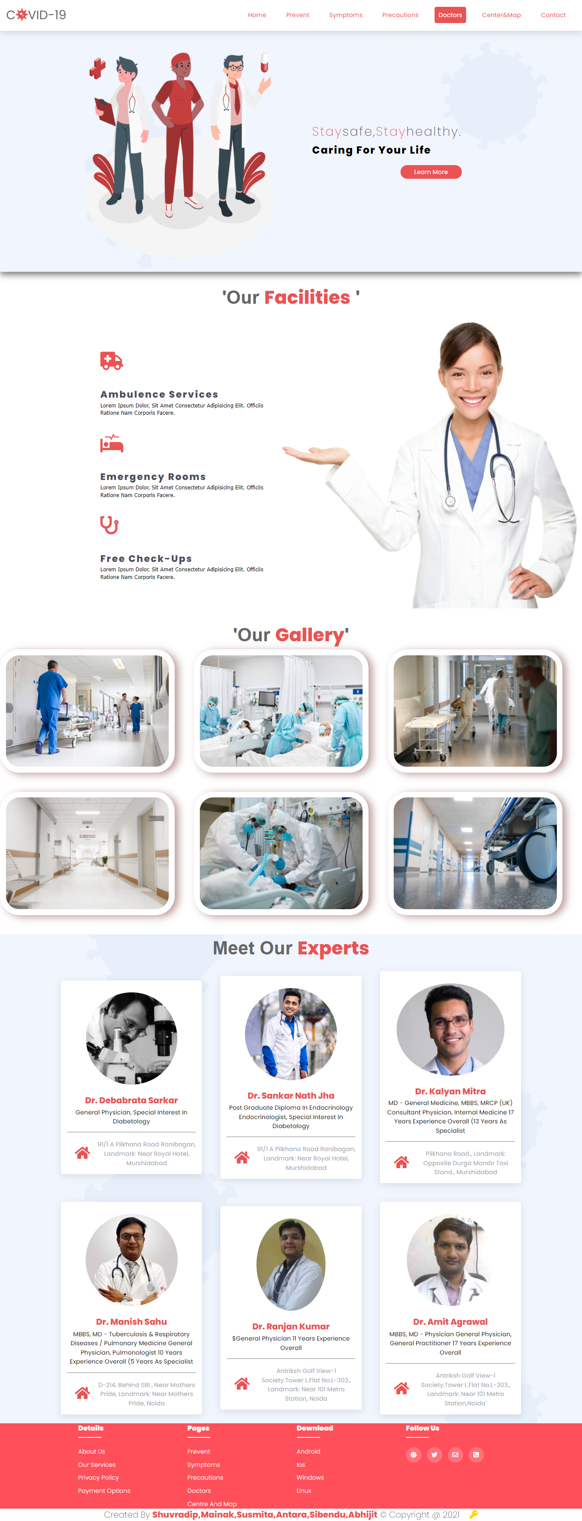

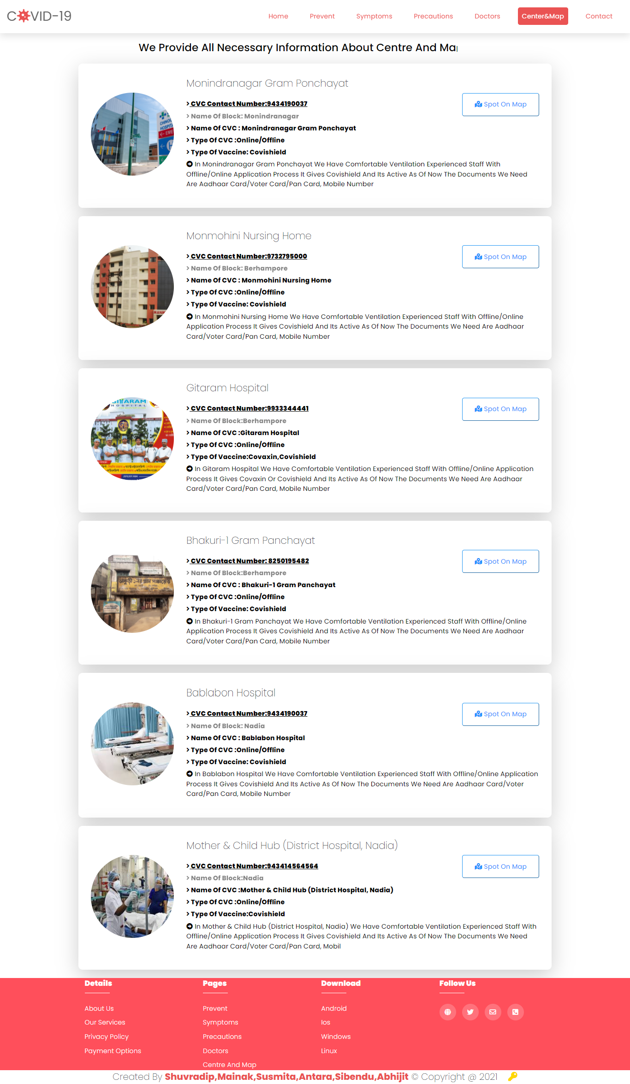

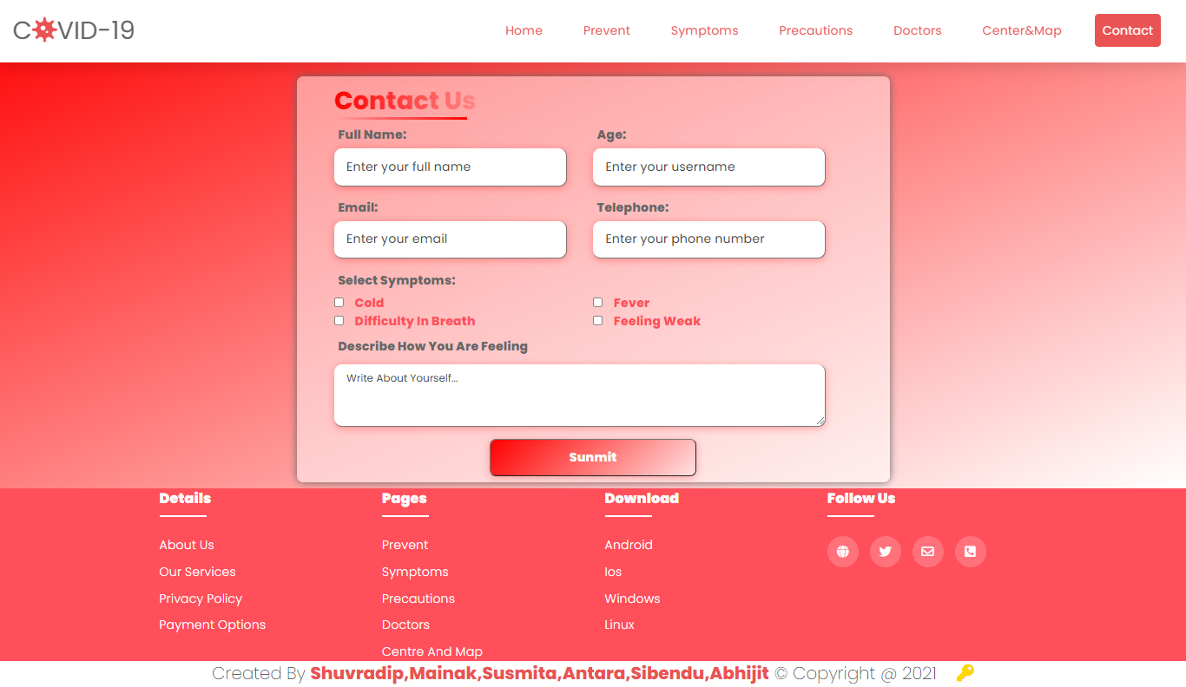

**CONCLUSION AND ENHANCEMENTS**

**Conclusion**

This system has been developed successfully incorporate all the requirements. Appropriate care has taken during database design maintain database integrity and to avoid redundancy of data. This site was developed in such a way that any further modifications needed can be easily done. User feels freely while using this site. In this, all technical complexities are hidden. This site is a more user friendly.

The quality focuses like correctness, efficiency, usability, maintainability, portability, accuracy, errors, tolerance, expandability and communicatively all are successfully done.

### Foreseeable enhancements

There is always a room for improvement in any software package, however good and efficient it may be. The important thing is that the website should be flexible enough for further modifications. Considering this important factor, the web site is designed in such a way that the provisions are given for further enhancements. At present this website provides all the information using forms. In future we can enhance our project by providing options like. Include many sites information.

**BIBLIOGRAPHY**

### JAVA SERVLETS

**-** TATA McGraw HILL

### SOFTWARE ENGINEERING

- McGraw-Hill Publications

**[J2EE-Overview]** - <http://java.sun.com/j2ee/overview.html>

### [JS-NET] -

<http://developer.netscape.com/docs/manuals/communicator/jsref/contents.htm>

**[J2EE-Home]** - <http://java.sun.com/j2ee/>

**[J2EE-Components]** - <http://java.sun.com/j2ee/blueprints/platform_technologies/component/index.html>

**[SUN-Developer]** - <http://developer.java.sun.com/developer/>